AML Programming Assignment II : Gibbs Sampling

**Name : Sunandan Adhikary**

**Roll : 21CS91R14**

**Prerequisites and Execution :**

* Run ‘python 21CS91R14_GibbsSampling.py’ in the directory of the provided python file

**Methodology implemented:**

1. A method *conditional_gaussian(joint_mean, joint_covariance, given_index_value_list, conditional_on)* to derive conditional Gaussian mean and co-variance of a single gaussian variable from the set of observable set of variables.
2. A method *gibbs_sampler(joint_mean, joint_covariance, given_index_value_list)* is implemented to derive the Gibbs sampling of each variables given their joint mean and co-variance and an initial set of observations.
3. We start from an initial value of 0.5 for each of the 900 variables that signify intensity values for the pixels in a 30x30 image. In each of the 10 iterations we sample each of those variables from the derived conditional distribution while the other variable values are given.
4. Means are set as (i+j)/100 for (i,j)-th pixel with a 0.1 variance (no co-variance or diagonal co-variance matrix)

This figure shows how means are distributed along the pixels (variance = 1e-4)

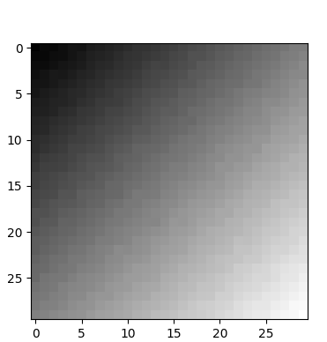

1. Note that :
   1. Each variables are sampled sequentially and the sampled value is updated in the list of the given values while sampling the next variable.
   2. Each of the values are within [0,1] since their mean does not cross 0.3 and variance is limited to 0.1.
   3. The simulation takes a long time considering high dimensions.

**Results :**

After 10 iterations here are some samples generated using the Gibbs sampling method for the given set of 900 variables (that signify pixel intensities) for a provided joint mean and co-variance values.

